Agentic AI Assignment 3
Real-Time Airspace Copilot with Agentic Multi-Agent System
Hafsa Siddiqua, Malaika Saleem
Course: Agentic AI
Date: 30 November 2025

1. Introduction & Problem Statement
Modern air travel requires timely monitoring of flights to ensure safety and improve passenger experience. Travelers often lack real-time situational awareness about their flights, while operations teams need to detect anomalies in airspace quickly.
This project builds a real-time Airspace Copilot system with two main perspectives:
- Airspace Operations View: Monitors flights in a region, detects anomalies, and provides summaries for operations staff.
- Traveler View: Lets passengers track individual flights with real-time updates and natural-language explanations via a chatbot.
The system uses a multi-agent architecture, integrating CrewAI agents, the MCP server, n8n workflows, and the Groq LLM API, all running locally.

2. System Architecture
The architecture consists of four main components:

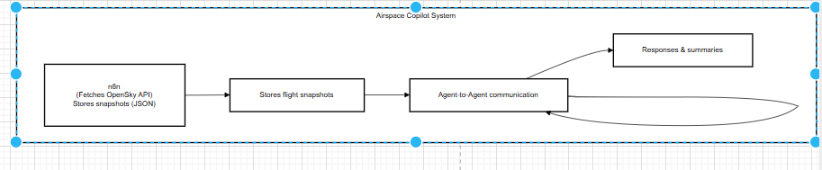
- n8n: Fetches live flight data from OpenSky API, filters fields, and stores snapshots in JSON.
- MCP Server (FastAPI): Exposes flight data as tools (flights.list, flights.get, alerts.list) to agents.
- CrewAI Agents (Groq LLM):
  - Ops Analyst Agent: Detects anomalies and summarizes operations view.
  - Traveler Support Agent: Answers traveler queries and can consult Ops Analyst via agent-to-agent (A2A) calls.
- Frontend/UI: Simple web or CLI interface allowing traveler and operations interactions.

3. Data Handling & n8n Workflows
- Data Source: OpenSky Network API (anonymous endpoints).
- Workflow Steps:
  - Fetch flight states periodically or on demand.
  - Filter relevant fields: ICAO24, callsign, latitude, longitude, altitude, velocity, heading, timestamp.
  - Store snapshots in region1_latest.json (primary) or fallback data/flights.json.
  - Expose HTTP webhook for agents and frontend to retrieve the latest snapshot.
- Fallback Handling: Cached snapshots ensure functionality when API rate limits occur or data is unavailable.

4. MCP Server & Tools
The MCP server abstracts flight data and exposes three main tools:
- flights.list(region): Returns all flights in a specified region.
- flights.get(identifier): Retrieves data for a specific flight by callsign or ICAO24 ID.
- alerts.list(): Returns currently flagged anomalies.
All agents query flight information exclusively through MCP tools, ensuring data encapsulation and modularity.

5. Agentic Layer

5.1 Ops Analyst Agent
- Role: Analyze regional snapshots, detect anomalies, generate summaries.
- Sample anomaly checks:
  - Low speed at high altitude
  - Rapid altitude changes
  - Stationary flights
- Sample Groq LLM prompt:
“Summarize the status of flights in Region 1, highlighting anomalies and critical cases.”

5.2 Traveler Support Agent
- Role: Answer user queries about a specific flight.
- Capabilities:
  - Natural-language explanation of flight position, altitude, speed, heading.
  - Can delegate nearby anomaly checks to Ops Analyst (A2A communication).
- Example A2A call:
from agents.agents_registry import AgentRegistry
registry = AgentRegistry()
result = registry.call_agent("ops_analyst", {
"task": "check_nearby_anomalies",
"latitude": 41.0,
"longitude": 29.0,
"radius_km": 50.0
})

6. Frontend Design
- Traveler Mode: Input field for flight identifier and chat interface for questions.
- Operations Mode: Dropdown to select region, table displaying flights with anomaly labels, and natural-language summary.
- UI Features:
  - Shows last updated timestamp
  - Displays structured flight data and LLM-generated summaries

7. Limitations & Future Work
Current Limitations:
- No live map visualization (lat/lon numeric only).
- Anomaly detection is basic threshold-based.
- Only one region implemented for demonstration.
Future Improvements:
- Add interactive map visualization.
- Improve anomaly detection with ML models.
- Support multiple regions dynamically.
- Expand A2A communication for cross-region insights.

8. Conclusion
This project demonstrates a fully agentic, multi-agent system for airspace monitoring. By integrating CrewAI agents, MCP server tools, and LLM reasoning, it provides both operational oversight and traveler assistance in real time. The system is robust to OpenSky API downtime through cached snapshots and supports realistic agent-to-agent interactions.

Deliverables Submitted:
- Technical Report (this document)
- Source code:
  - n8n workflows
  - MCP server
  - CrewAI agents
  - Frontend/UI
- Demo video showcasing data fetch, traveler queries, operations summary, and anomalies

